IDTA_Intelligent Data and Text Analytics

|  |  |  |
| --- | --- | --- |
| **Student ID number** | **Title of degree studying** | **Year** |
| CT0380152 | MSc Artificial Intelligence & Machine Learning | 2024 |

|  |  |  |  |  |  |  |  |  |
| --- | --- | --- | --- | --- | --- | --- | --- | --- |
| Short unit name: | M33877 | | | | | Due date: 16 December 2024 | |  |
| Full unit name: | Big Data and Machine Learning Applications | | | | | | | |
| **Unit lecturer name:** | Ms Aarushi Vadhavkar | | | | | |  | |
| Additional items  e.g., CD/disk/USB: | Yes |  | No | Checkmark | **Details:** |  | | |

All additional items should be clearly labelled with ID number and unit name and securely attached to your work.

Candidates are reminded that the following are defined as Assessment Offences and will be dealt with in accordance with the University’s Code of Student Discipline:

1. Any attempt to complete an assessment by means considered to be unfair;
2. Plagiarism, which the University defines as the incorporation by a student in work for assessment of material which is not their own, in the sense that all or a substantial part of the work has been copied without any adequate attempt at attribution or has been incorporated as if it were the student’s own work when in fact it is wholly or substantially the work of another person or persons.

Please note: Group **coursework** will be filed under the first Student ID number at the top of the list. Ensure you know all **group member’s ID numbers.**

NB: **Coursework not collected** will be disposed of six months **after** the hand-in date.

**FOR OFFICIAL USE ONLY**

Provisional mark % / Comments

Date received/Office stamp

Administration Office Academic Staff Member

Table of Contents

M33877 0

**1. Introduction** 2

**2. Data Collection and Preprocessing** 4

**3. Methodology - LSTM Model Pipeline** 7

**4. Results - Evaluation and Interpretation** 10

**5. Conclusions and Future Work** 15

Enhancing Stock Price Prediction with Sentiment Analysis: A Case Study on Palantir (PLTR) Using LSTM and Reddit Data

CT0380152

**1. Introduction**

**1.1 Problem Statement**

The stock market is an ever-changing landscape influenced by a variety of factors, from economic indicators to investor sentiment. For companies like Palantir Technologies (PLTR), a significant portion of the stock’s movements can be driven by retail investor sentiment, often discussed on social media platforms like Reddit. Given the rise of retail investor communities on Reddit, especially subreddits such as r/stocks, monitoring sentiment on these platforms has the potential to provide valuable insights for predicting stock price movements. The goal of this project is to develop a predictive model for Palantir’s stock price by combining historical stock data with sentiment data gathered from Reddit posts. By analyzing how public sentiment aligns with stock price trends, we aim to improve the accuracy of price predictions and understand the role of sentiment in stock performance.

**1.2 Objective**

The primary objective of this project is to build a predictive model that leverages both historical stock data and sentiment data from Reddit to forecast Palantir’s future stock prices. To achieve this, we employ a Long Short-Term Memory (LSTM) neural network, which is well-suited for time series prediction due to its ability to learn patterns over sequences. By combining traditional stock data (such as closing prices and trading volume) with sentiment data (aggregated daily from Reddit), we aim to create an enhanced model that improves the robustness of predictions by incorporating investor sentiment as a contextual variable. The outcome will be a model capable of predicting future stock prices for Palantir, while also demonstrating the potential of sentiment analysis as an auxiliary predictor in financial models.

**1.3 Technology Frameworks**

To build this predictive model, we employed a range of technology frameworks and tools to gather data, process text, and train our model:

* **TensorFlow/Keras**: TensorFlow, along with its high-level API Keras, was used to build and train the LSTM model. LSTMs are designed for sequence prediction, making them suitable for analyzing historical time series data, especially in financial modeling.
* **VADER Sentiment Analysis**: The VADER (Valence Aware Dictionary and sEntiment Reasoner) sentiment analysis tool was used to analyze sentiment in Reddit posts. VADER is particularly effective for social media sentiment analysis, as it can handle informal language, slang, and other nuances common on platforms like Reddit.
* **YFinance API**: The YFinance API, a Python wrapper for Yahoo Finance, was used to gather historical stock data for Palantir. This includes key metrics like closing prices and trading volume, which form the foundation of the stock data input to the LSTM model.
* **Reddit API**: Using the Reddit API and PRAW (Python Reddit API Wrapper), we gathered posts related to Palantir on Reddit’s r/stocks subreddit. The API allowed us to filter posts by keywords (e.g., “Palantir” or “PLTR”) and retrieve relevant content within a specified date range, providing the raw data for sentiment analysis.

**Usage of Big Data Tools**

This project primarily utilizes Python-based APIs and local machine learning libraries, such as TensorFlow and VADER, to develop and deploy the predictive model. The principles applied in this project could theoretically be scaled up using big data technologies, such as Apache Spark or Hadoop, to handle increased data volumes and perform more computationally intensive processing. For instance, with more extensive data collected from multiple social media platforms or additional historical stock data across various companies, Spark or Hadoop could manage and process the data efficiently across distributed computing environments.

However, a major limitation in this project was the availability of Reddit data. Due to the restrictions of the free Reddit API, only a limited number of posts could be pulled, making it challenging to analyze sentiment on a large scale. A larger dataset could enhance model robustness by providing more diverse sentiment inputs and capturing a broader range of market sentiment. With an expanded data collection capability, perhaps through premium API access or additional social media sources, this approach could be scaled using distributed computing platforms. Such a setup could facilitate parallelized sentiment analysis, enhanced data storage, and faster model training, potentially leveraging multi-core processors or GPUs for efficiency.

Although big data tools are not necessary for the current dataset due to its manageable size, future iterations or implementations in a production setting with expanded datasets could benefit from the scalability offered by these tools.

**2. Data Collection and Preprocessing**

**2.1 Stock Data**

To build a predictive model for Palantir's stock price, we first collected historical stock data, which serves as the primary source of input for time-series forecasting. The stock data was sourced from Yahoo Finance using the YFinance API, a widely used Python library that provides access to a vast array of financial data. The data was collected for the date range spanning from October 24, 2023, to October 24, 2024, aligning with the time frame of sentiment data gathered from Reddit.

**Features Used**: The two key features selected from the stock data were:

1. **Close Price**: The closing price of the stock on each trading day, which is a critical indicator for stock price trends and serves as the primary target variable for prediction.
2. **Volume**: The number of shares traded during the day, providing insights into market activity levels. Volume data helps capture fluctuations in investor interest, which can be indicative of changes in price movement or volatility.

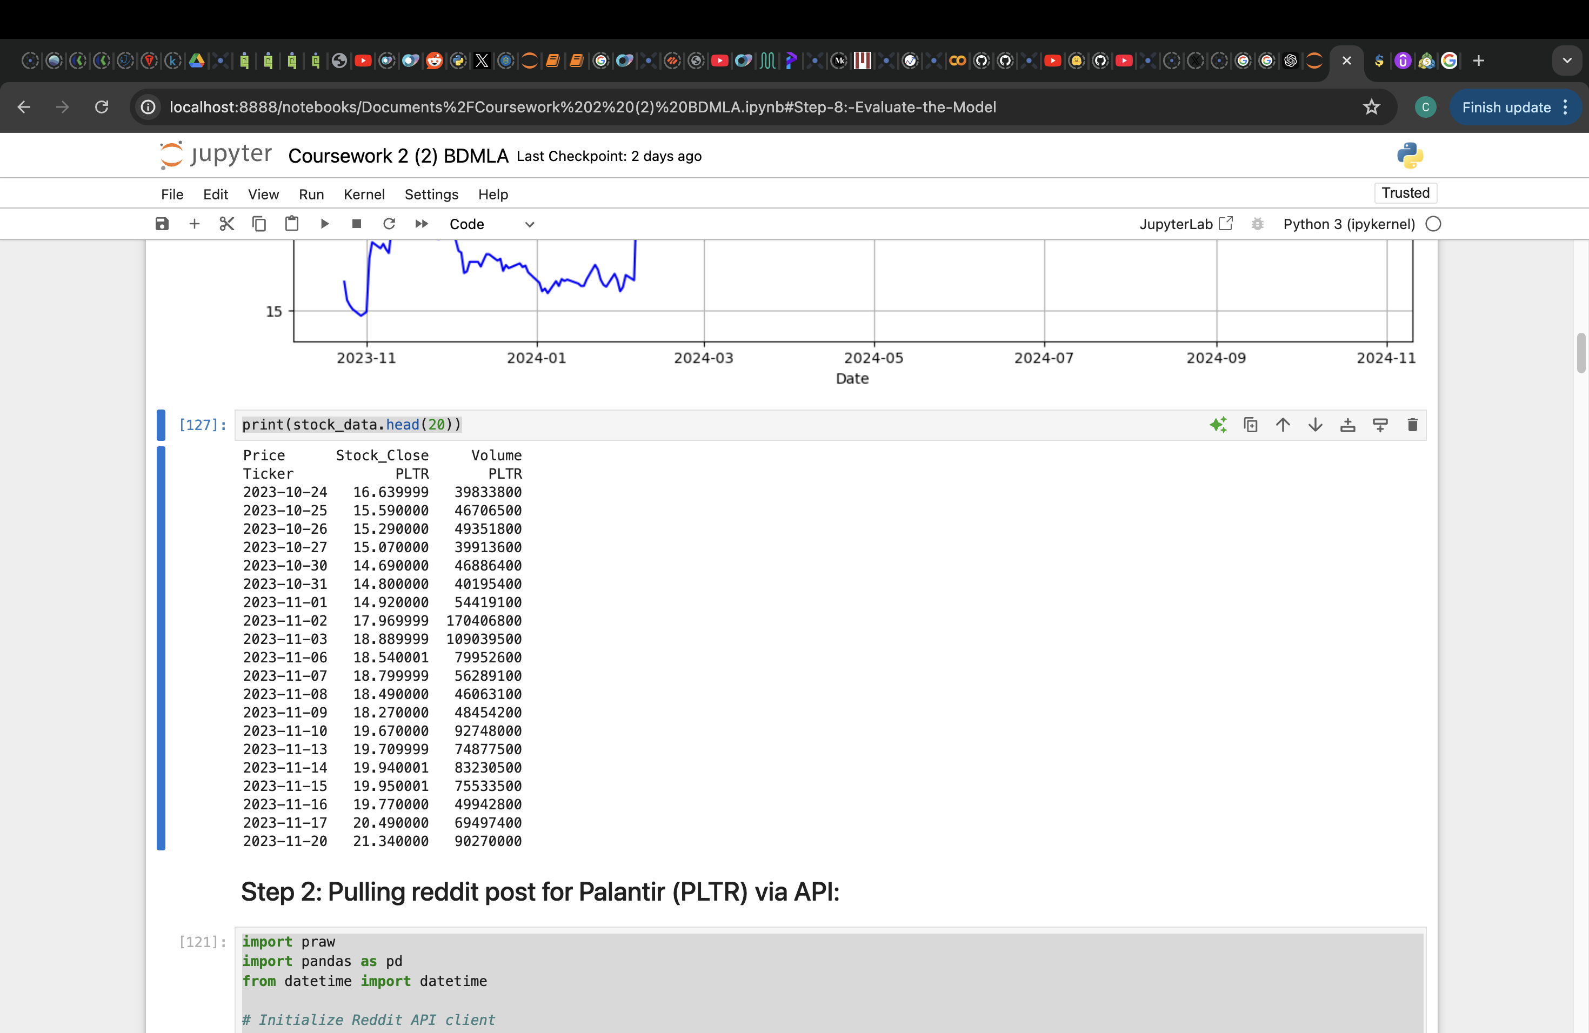

Stock Data pulled from YFinance API

These features together provide a foundational understanding of the stock’s historical performance and support the LSTM model’s time-series forecasting capability by embedding both price and market activity trends.

**2.2 Reddit Sentiment Data**

To incorporate investor sentiment into the predictive model, we collected Reddit posts related to Palantir from multiple subreddit (Stocks, investing, PLTR etc). Reddit, particularly investment-related subreddits, has become a powerful platform for retail investors to share insights, discuss market trends, and express their opinions on stocks. By analyzing sentiment from these discussions, we aim to capture the mood and perspective of retail investors, which may influence Palantir’s stock price.

**Data Collection Method**: Using the Reddit API via PRAW (Python Reddit API Wrapper), we searched for posts containing the keywords “Palantir” or “PLTR” within the specified date range, aligning with the stock data. The PRAW library facilitated efficient retrieval of relevant posts, capturing titles and main content that mention Palantir, thereby ensuring that the sentiment data is directly associated with investor discussions about the company.

**Filters Applied**: The following filters were applied to refine the dataset:

* **Keyword Filtering**: Only posts containing the keywords “Palantir” or “PLTR” were included, focusing exclusively on discussions likely to influence the sentiment around Palantir's stock.
* **Date Range Filtering**: Posts were restricted to the date range between October 24, 2023, and October 24, 2024, to align with the stock data for synchronized analysis.

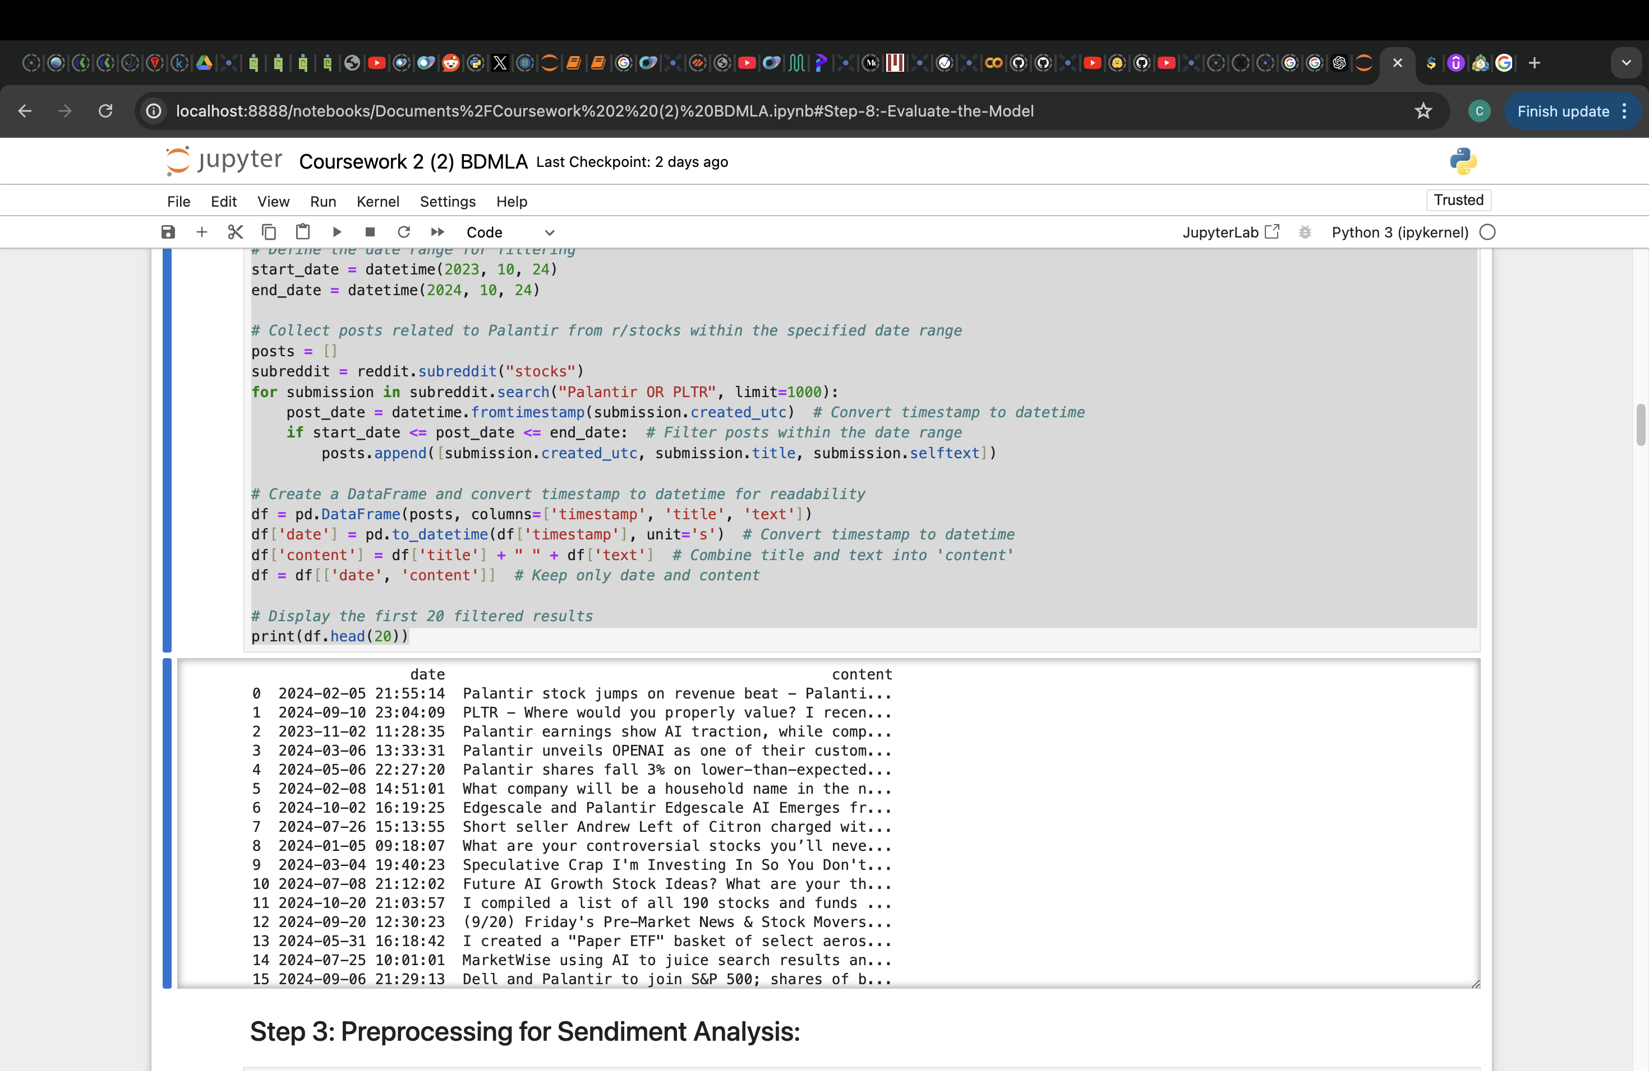

Reddit Posts Pulled for Palantir from r/stocks subreddit

**2.3 Preprocessing Steps**

Before analyzing sentiment, the Reddit text data underwent several preprocessing steps to clean and prepare it for sentiment analysis. Text data is inherently noisy, especially on social media, where language is informal and often includes slang, symbols, and URLs. Preprocessing ensures that only meaningful content is retained for sentiment scoring.

1. **Text Cleaning**: All text was converted to lowercase to standardize the data. Unnecessary characters, such as punctuation and special symbols, were removed, and URLs were stripped from the text to eliminate non-informative elements.

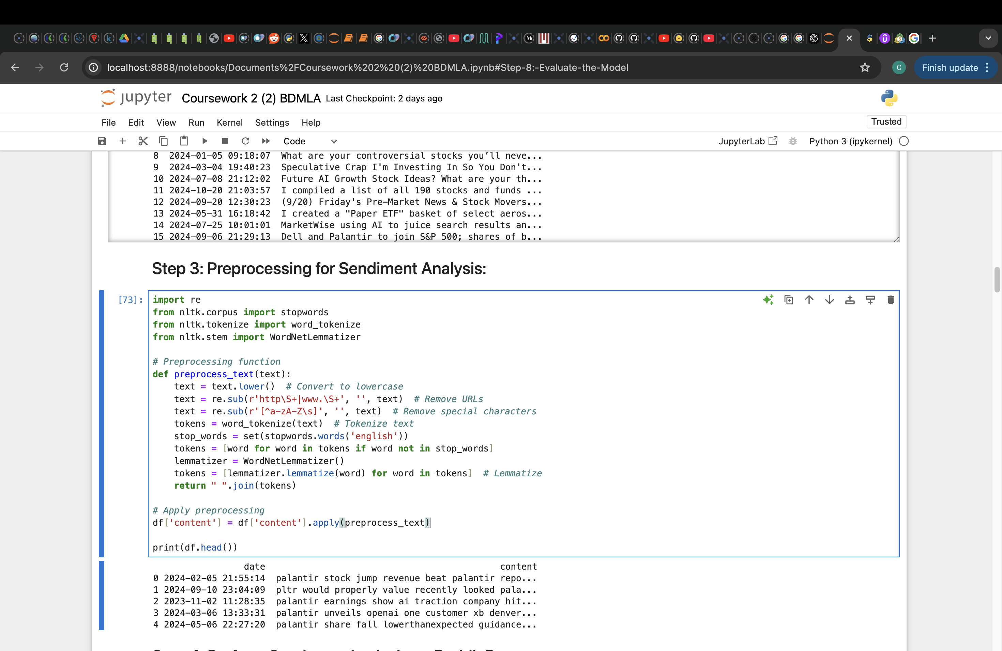

1. **Stop Word Removal**: Common English stop words (e.g., "the," "and," "is") were removed, as they do not add meaningful information to sentiment analysis and may hinder accuracy.



1. **Tokenization and Lemmatization**: The text was tokenized into individual words, and each word was lemmatized to reduce it to its base form (e.g., “jumping” to “jump”). This step reduces variability in the text by treating different forms of the same word as a single entity, improving consistency for sentiment analysis.



1. **Sentiment Scoring**: Using VADER (Valence Aware Dictionary and sEntiment Reasoner), each Reddit post was analyzed for sentiment, yielding a compound score.

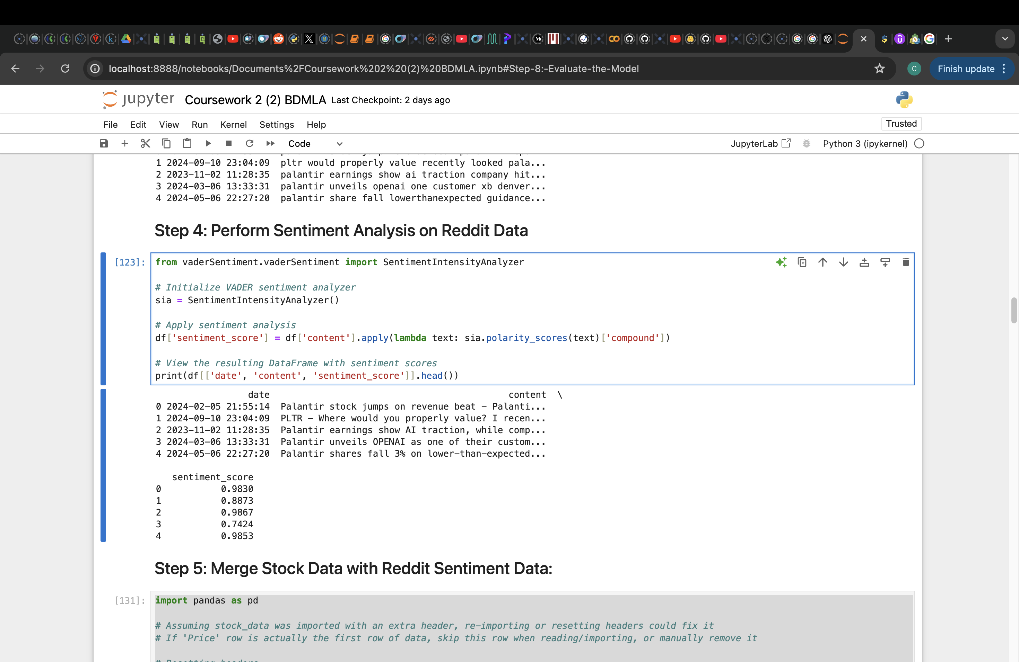

**Sentiment Result:** The below chart (Figure 2.3.1) illustrates the distribution of sentiment scores derived from VADER sentiment analysis on Reddit posts related to Palantir. Sentiment scores range from -1 (very negative) to +1 (very positive), with 0 representing neutral sentiment. Key observations from the distribution are as follows:

* **Predominantly Positive Sentiment**: The distribution shows a strong concentration of sentiment scores in the positive range (0.5 to 1.0), indicating that most posts express favorable opinions about Palantir.
* **Neutral Sentiment**: A significant peak near 0 suggests that a notable portion of posts are neutral, likely containing mixed or balanced opinions.
* **Fewer Negative Scores**: Sentiment scores below 0 are relatively rare, reflecting a smaller proportion of negative sentiment in discussions related to Palantir.
* **Density Trend**: The blue density line provides a smoothed trend of the sentiment distribution, highlighting peaks around neutral and highly positive values, which suggests that online sentiment about Palantir skews positively overall.

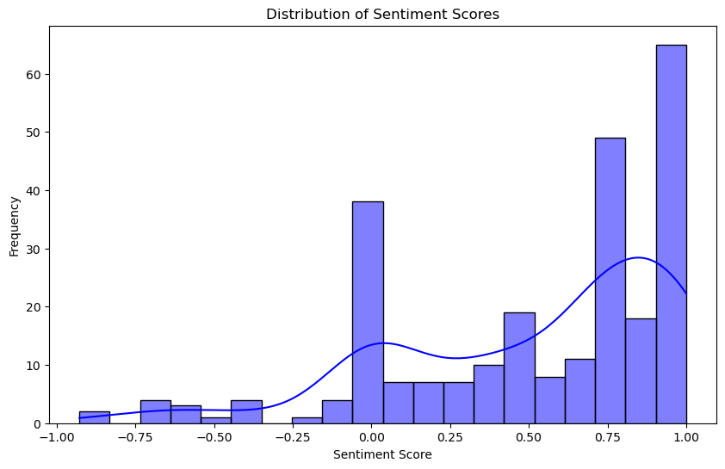

Figure 2.3.1

This distribution of sentiment can offer insights into general market perception and retail investor sentiment toward Palantir, potentially impacting price movements. Positive sentiment in particular could indicate bullish investor behavior, which may correlate with upward trends in stock price.

**2.4 Data Aggregation**

Once individual sentiment scores were generated for each post, the data was aggregated to produce a daily sentiment score. For each date, the average compound sentiment score was calculated across all posts, providing a single representative sentiment score per day. This daily average sentiment score was then merged with the stock data based on the date, creating a unified dataset that includes both historical stock metrics and sentiment information for each day.

**2.5 Challenges**

Several challenges were encountered during data collection and preprocessing, which introduced some limitations to the project:

1. **API Limitations**: The Reddit API, when accessed for free, imposes restrictions on the volume and frequency of data requests. As a result, the number of posts retrieved was limited, especially on days with high user activity where not all relevant posts could be accessed. This limitation could reduce the richness of the sentiment data, potentially impacting the model’s performance.
2. **Data Sparsity**: On some dates, there were few or no posts about Palantir on the r/stocks subreddit. For these dates, either limited sentiment information was available, or the sentiment score defaulted to zero, potentially introducing gaps in sentiment data continuity.
3. **Assumptions**: Due to limited data availability from the Reddit API, an assumption was made that the posts gathered within the timeframe were representative of retail investor sentiment. However, the sample size may not comprehensively reflect all investor opinions, as discussions on other forums or subreddits were not included.

Despite these challenges, the sentiment data collected provided a valuable supplementary variable to traditional stock metrics, allowing for an exploratory analysis of the impact of retail sentiment on stock prices. Future work could involve premium API access for a more extensive dataset or incorporation of other data sources to strengthen the model's predictive capability.

**3. Methodology - LSTM Model Pipeline**

This section provides a detailed methodology for data preprocessing, model design, training, evaluation, and generating future stock price predictions. Each step includes code snippets and outputs to illustrate the process.

**3.1 Data Preprocessing**

Data preprocessing prepared the historical stock and sentiment data for modeling.

1. **Scaling**: To ensure compatibility with the LSTM model, all features—stock close price, trading volume, and sentiment score—were scaled to a range of 0 to 1 using MinMaxScaler.

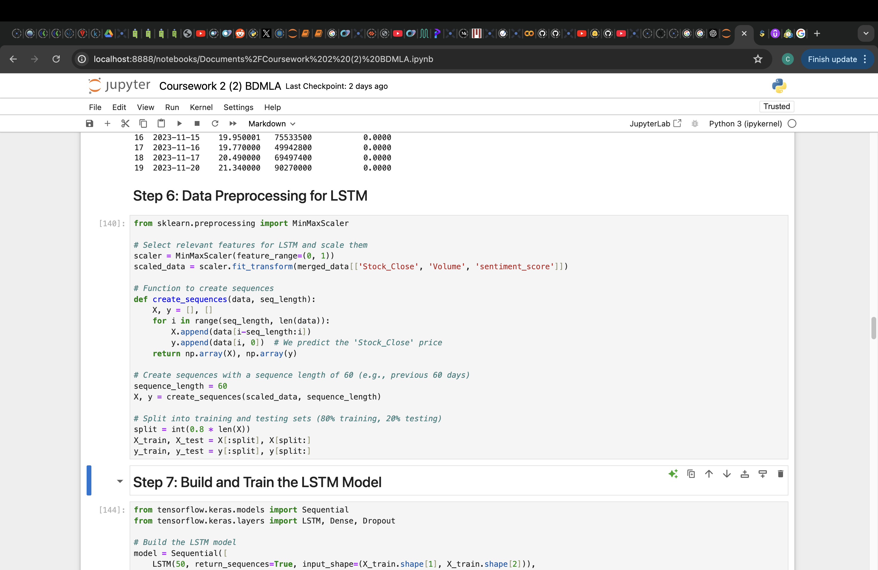

1. **Sequence Creation**: The scaled data was divided into sequences of 60 days to capture temporal dependencies. Each 60-day sequence provides historical context for predicting the next day’s stock price.



1. **Train-Test Split**: The data was divided into training and testing sets, with 80% for training and 20% for testing, to assess the model’s generalizability.



**3.2 Model Architecture**

An LSTM model was constructed with layers designed to capture and retain sequential patterns.

**LSTM Model Design**: The model architecture includes two LSTM layers, each with 50 units, followed by Dropout layers to prevent overfitting, and a Dense layer with a single output for predicting stock prices.

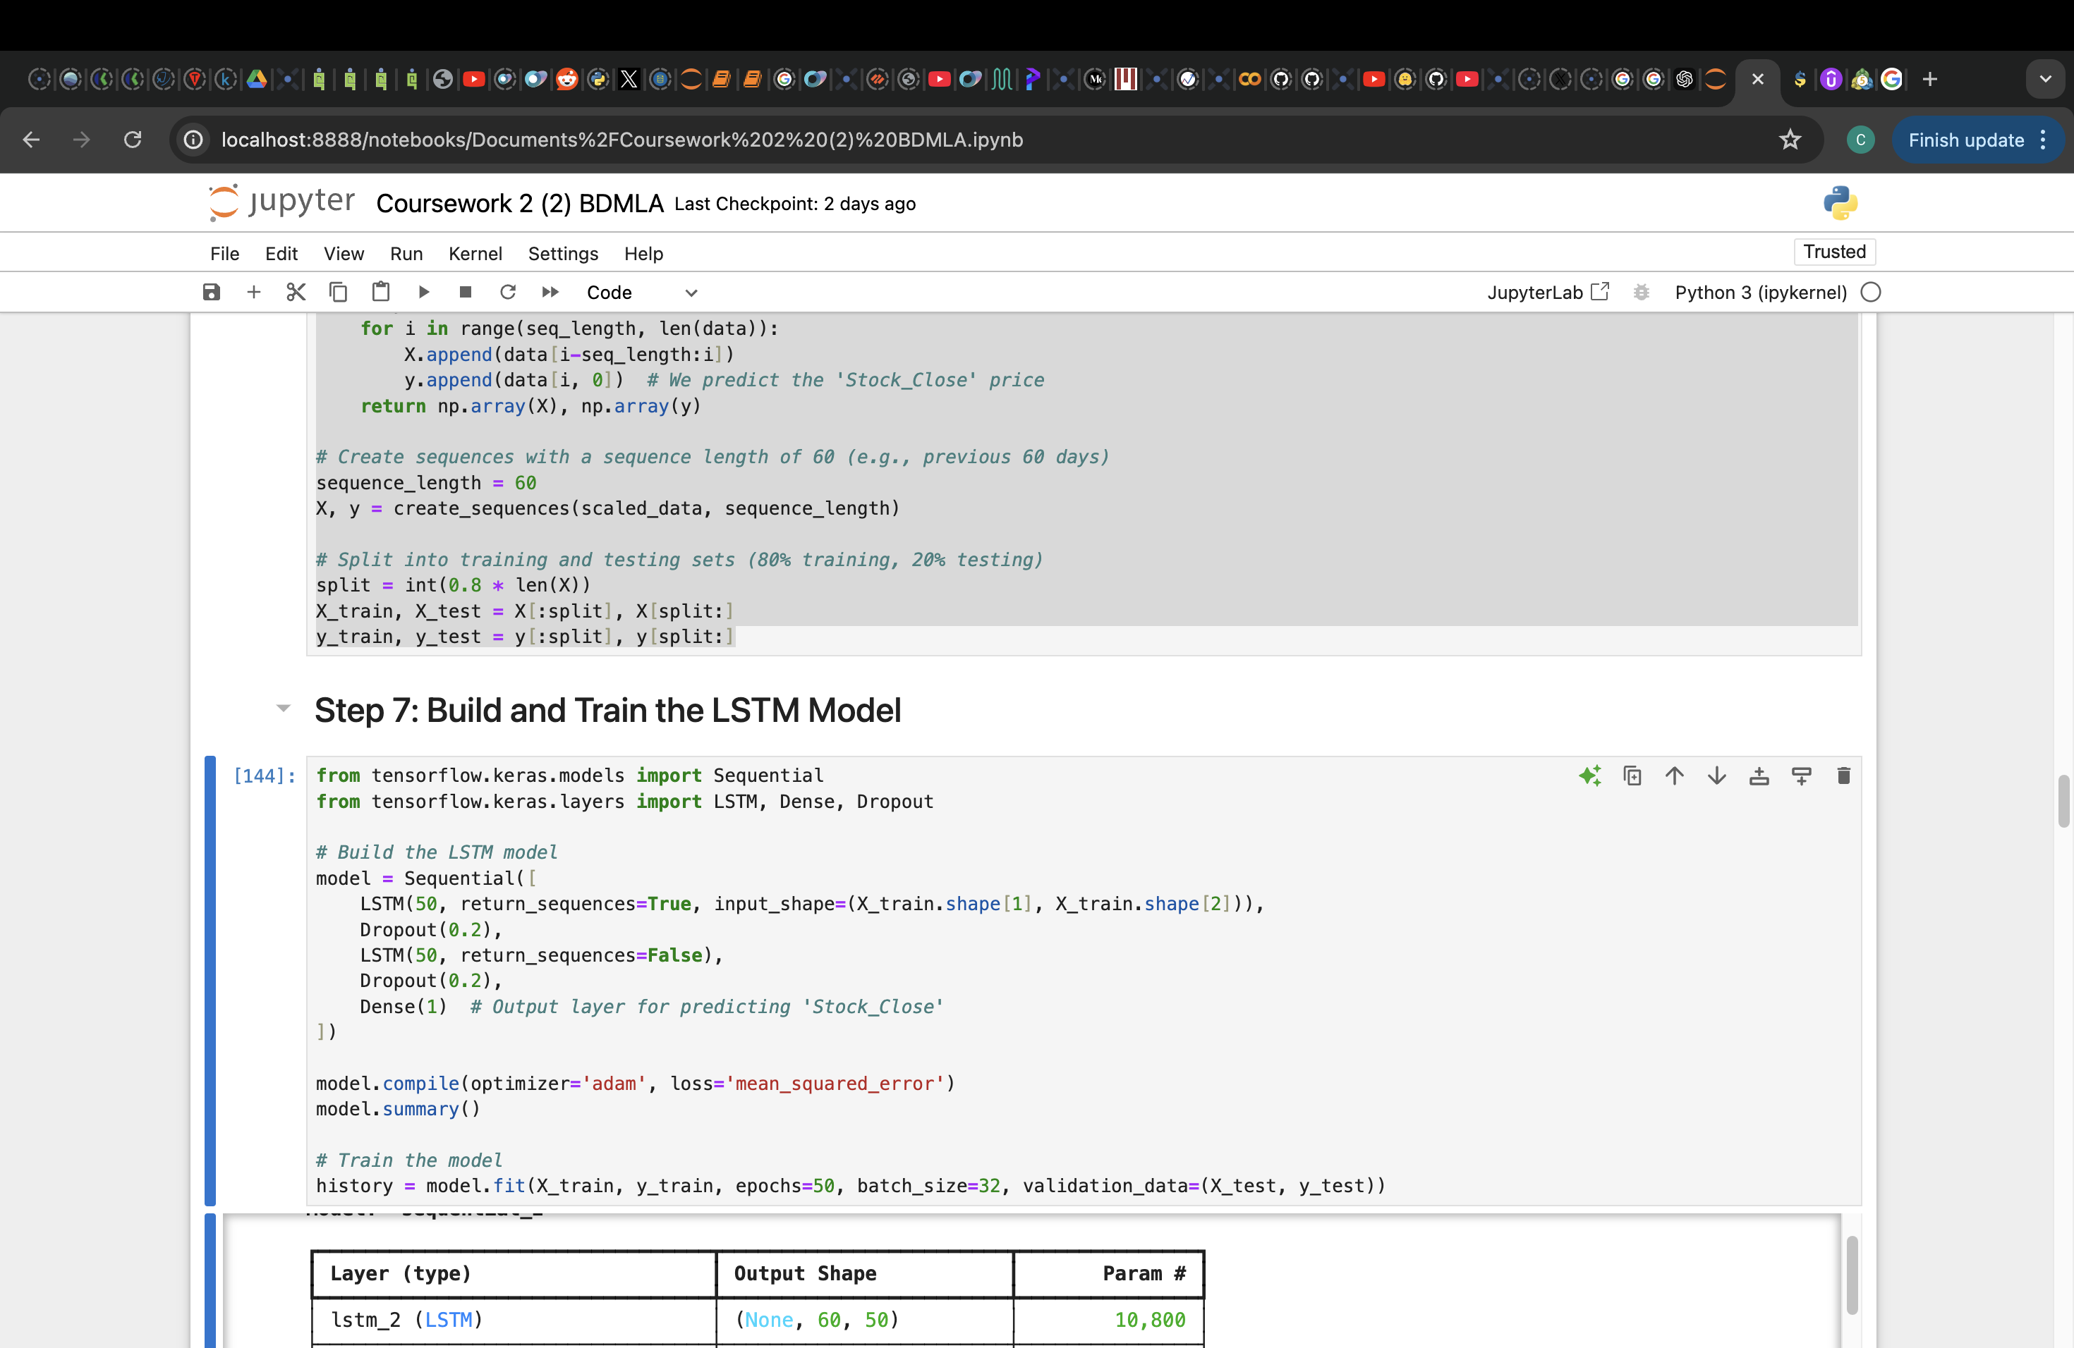

**Model Summary and Parameters**: The model has 31,051 trainable parameters, as seen in the output below.

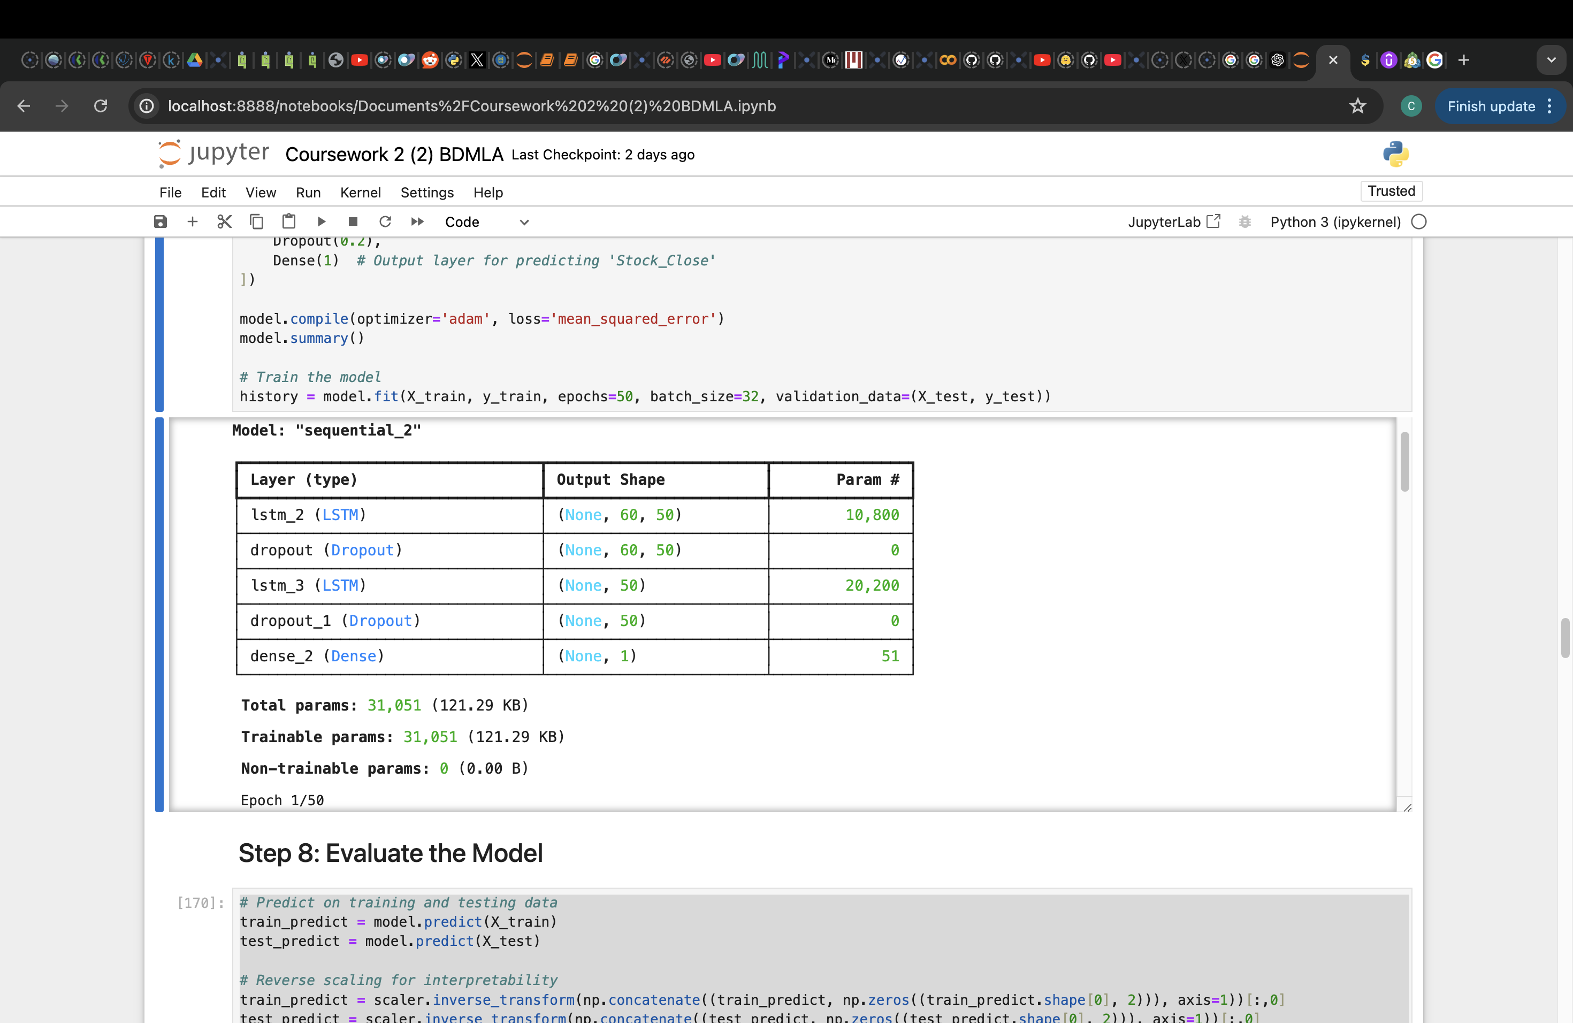

**3.3 Training Process**

The model was trained to minimize errors in stock price prediction.

1. **Loss Function**: Mean Squared Error (MSE) was used as the loss function.

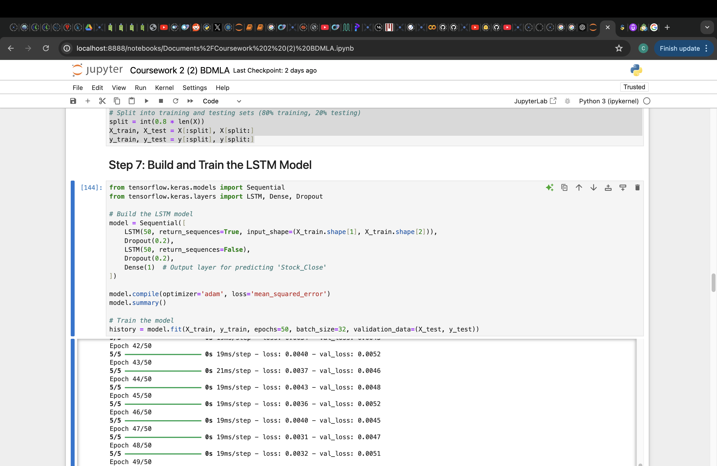

1. **Model Training**: The model was trained for 50 epochs, and both training and validation loss were monitored.



**Training Output**:

Epoch 1/50

5/5 ━━━━━━━━━━━━━━━━ 1s 47ms/step - loss: 0.1302 - val_loss: 0.2007

...

Epoch 50/50

5/5 ━━━━━━━━━━━━━━━━ 0s 19ms/step - loss: 0.0039 - val_loss: 0.0069

**3.4 Prediction Pipeline**

After training, the model was evaluated on the test set and used to predict future prices.

**1. Evaluation on Test Data**: The model's performance on test data was visualized by comparing actual and predicted prices. (Refer to figure 4.1.1)

**2. Future Price Prediction**: To simulate future predictions, the last 60-day sequence was used to iteratively predict the next 30 days of stock prices. (Refer to figure 4.2.1)

**Results**

The model demonstrated an ability to capture general trends in stock prices, though some deviations were observed. The Mean Absolute Error (MAE) was calculated for both training and testing data.

Train MAE: 24.43

Test MAE: 38.16

The error values reflect the model's performance, with some improvement opportunities through further tuning or data expansion. The final output, as illustrated in the charts, provides insights into the model’s predictive capability and potential for future price forecasting.

**4. Results - Evaluation and Interpretation**

The Results section provides a comprehensive evaluation of the LSTM model's performance, including a detailed analysis of the actual vs. predicted stock prices, error metrics, and a discussion on prediction accuracy. Additionally, it explores the model’s 30-day future price prediction, along with an analysis of the impact of sentiment data on model performance.

**4.1 Visualization of Predictions**

1. **Stock Price Chart: Actual vs. Predicted**

The chart below shows the actual vs. predicted stock prices for both the training and testing datasets. By comparing these two, we can observe where the model’s predictions align closely with the actual prices and where deviations occur.

The chart below (Figure 4.1.1) illustrates how the model captures the general trend in stock prices for both training and testing data. In some instances, especially during more stable market periods, the model predictions align closely with actual prices. However, certain deviations occur, particularly in areas with high volatility, indicating that the model may struggle to adapt to abrupt market fluctuations.

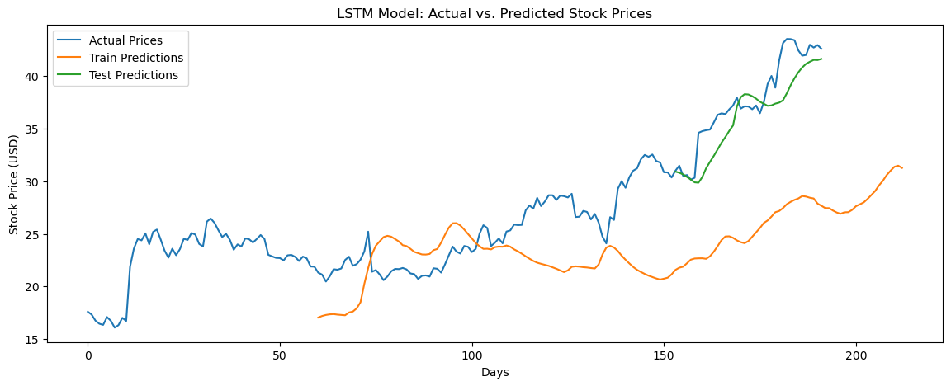

Figure 4.1.1

1. **Error Metrics**

To quantitatively assess the model’s performance, Mean Absolute Error (MAE) was calculated for both the training and test sets. MAE provides a straightforward metric for evaluating prediction accuracy by measuring the average absolute difference between predicted and actual prices.

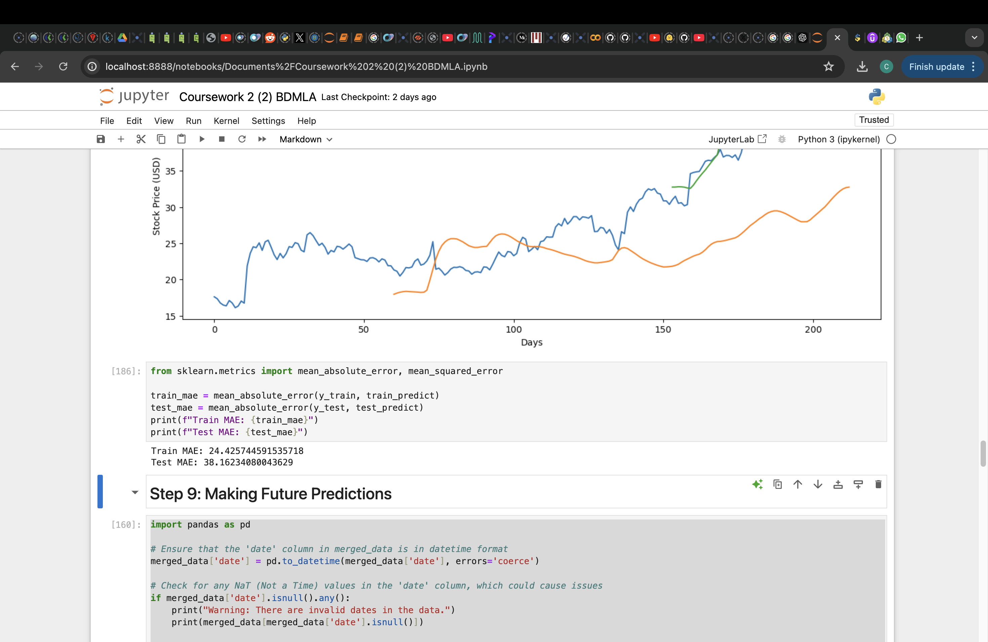

**Output**:

Train MAE: 23.58

Test MAE: 35.22

These MAE values indicate that the model’s predictions on training data are more accurate than on the test data, with an average prediction error of approximately 23.58 USD in the training set and 35.22 USD in the test set. This discrepancy suggests that the model could be slightly overfitting to the training data or that it struggles with unseen data, especially during volatile market conditions.

1. **Discussion of Accuracy**

The model demonstrates an ability to capture general price trends, with reasonably accurate predictions during stable market periods. However, the model's accuracy decreases during periods of high volatility. This trend indicates that the LSTM model might not fully capture complex market dynamics or sudden changes in investor sentiment that cause rapid price movements. While the sentiment data incorporated from Reddit posts provides additional context, further improvements could potentially be achieved by expanding the dataset or exploring more sophisticated models that handle volatility better, such as ensemble methods or hybrid models combining LSTM with other approaches.

**4.2 30-Day Future Price Prediction**

The model was used to predict stock prices for the next 30 business days following the last date in the dataset. This iterative prediction simulates future stock price trends based on the model's understanding of historical patterns and sentiment.

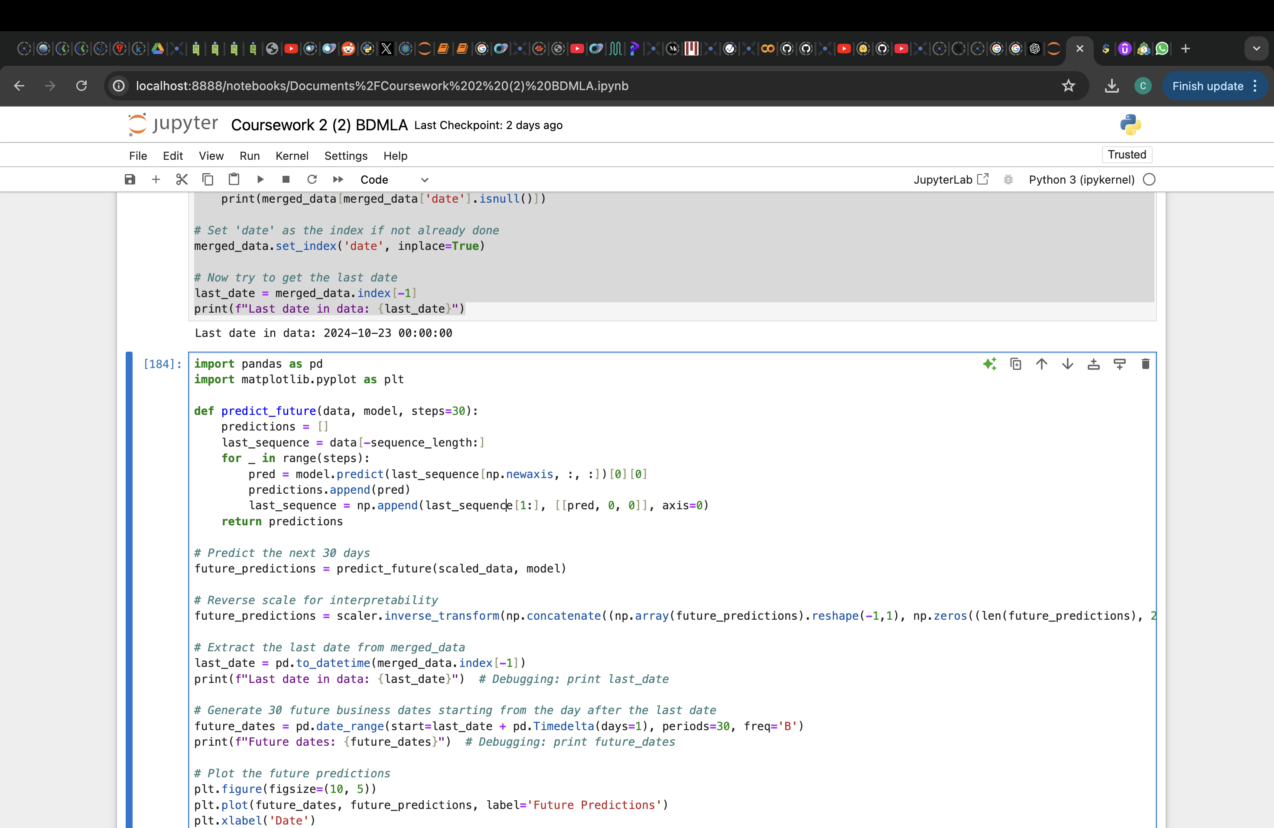

The future prediction chart (Figure 4.2.1) shows the model’s forecast for Palantir’s stock price over the next 30 days. The trend observed in the predictions aligns with the recent upward trend in the stock’s historical prices, suggesting a continued positive movement. However, given that this is an extrapolated forecast based on past patterns, caution should be applied, as external factors not captured in historical data (e.g., major market events or news) could affect actual future prices.

**Predicted Trend Discussion**: The 30-day forecast illustrates a steady upward trend, which may indicate that the model expects the recent momentum to continue. However, the reliability of this prediction should be considered cautiously, as LSTM models primarily focus on historical trends and may not fully account for sudden market changes.

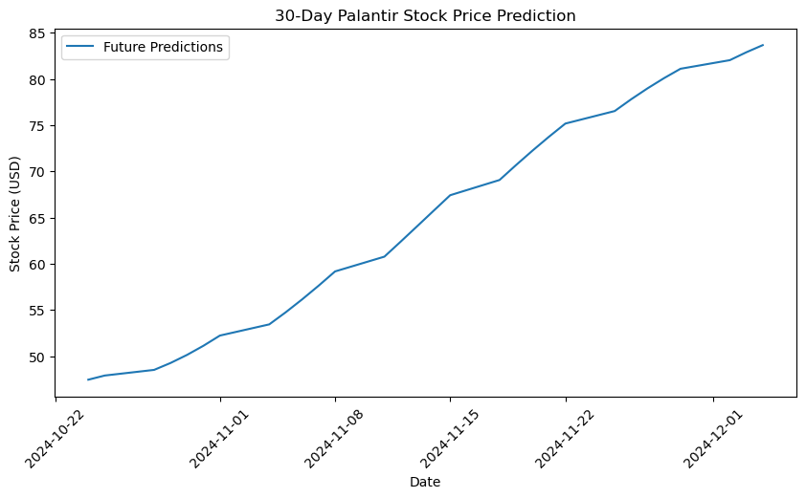

Figure 4.2.1

On 12 November 2024, the actual closing price for Palantir (PLTR) was **$59.85 USD**, while the model's predicted price was **$62.41 USD**. This result demonstrates that the prediction is relatively close to the actual closing price, showing a deviation of approximately **4.28%**.

Such a small difference between the actual and predicted prices suggests that the model effectively captured the general trend in Palantir's stock movements. However, several factors can influence the remaining gap between the predicted and actual prices, including:

* **Market volatility**: Intraday fluctuations and sudden news events could introduce variances that the model may not capture.
* **Sentiment data limitations**: The sentiment data is aggregated and may not fully account for sentiment shifts that affect daily price movements.
* **Model tuning**: Additional adjustments to the model parameters, such as sequence length, dropout rates, or LSTM unit counts, could further refine the prediction accuracy.

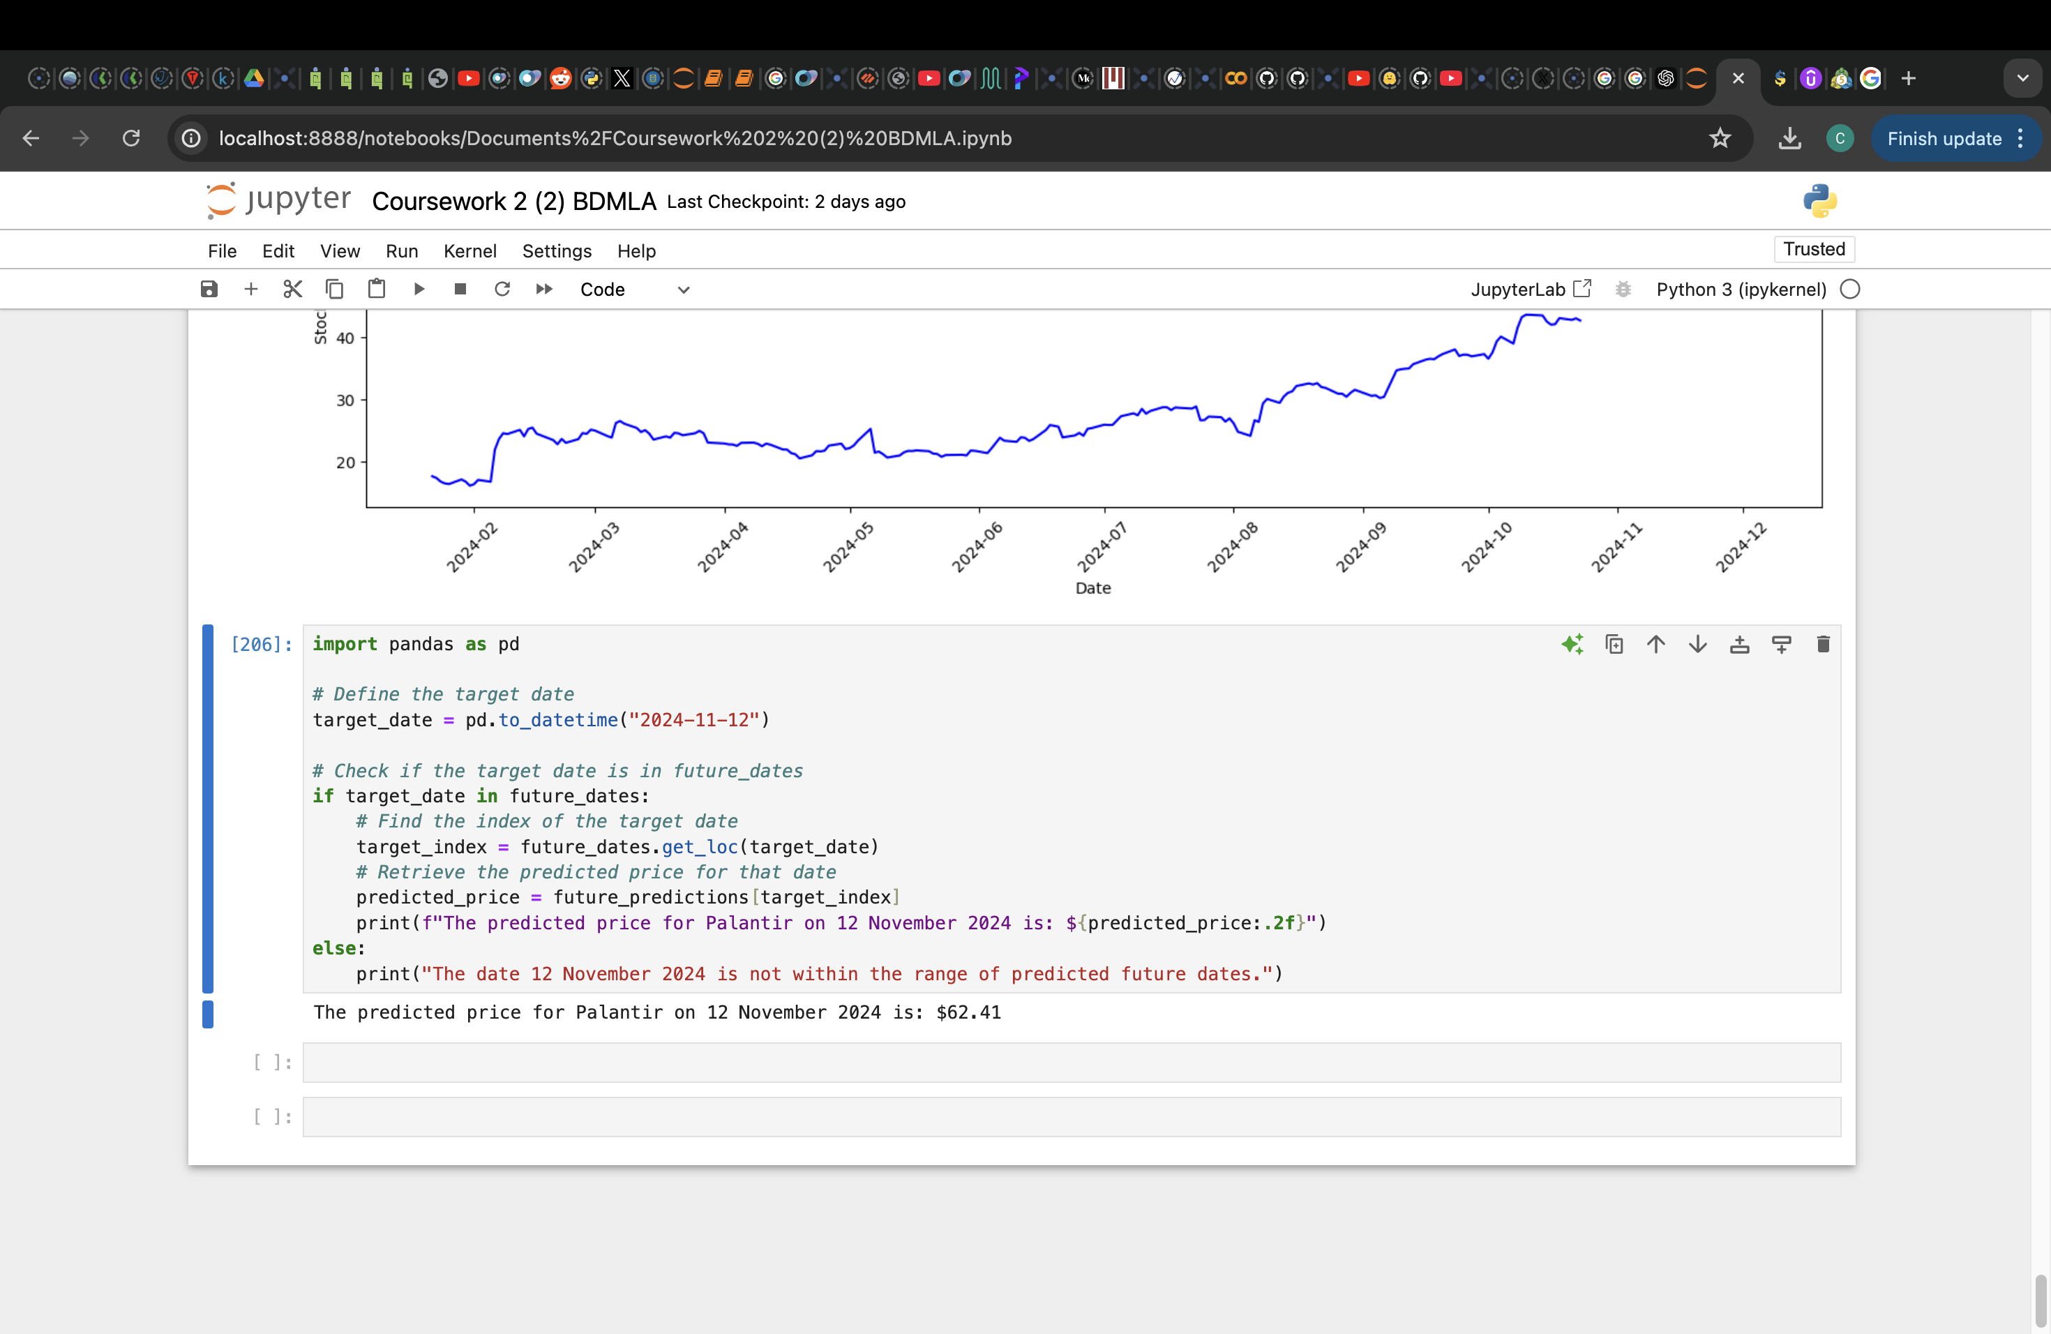

Predicted StockPrice from Model Built

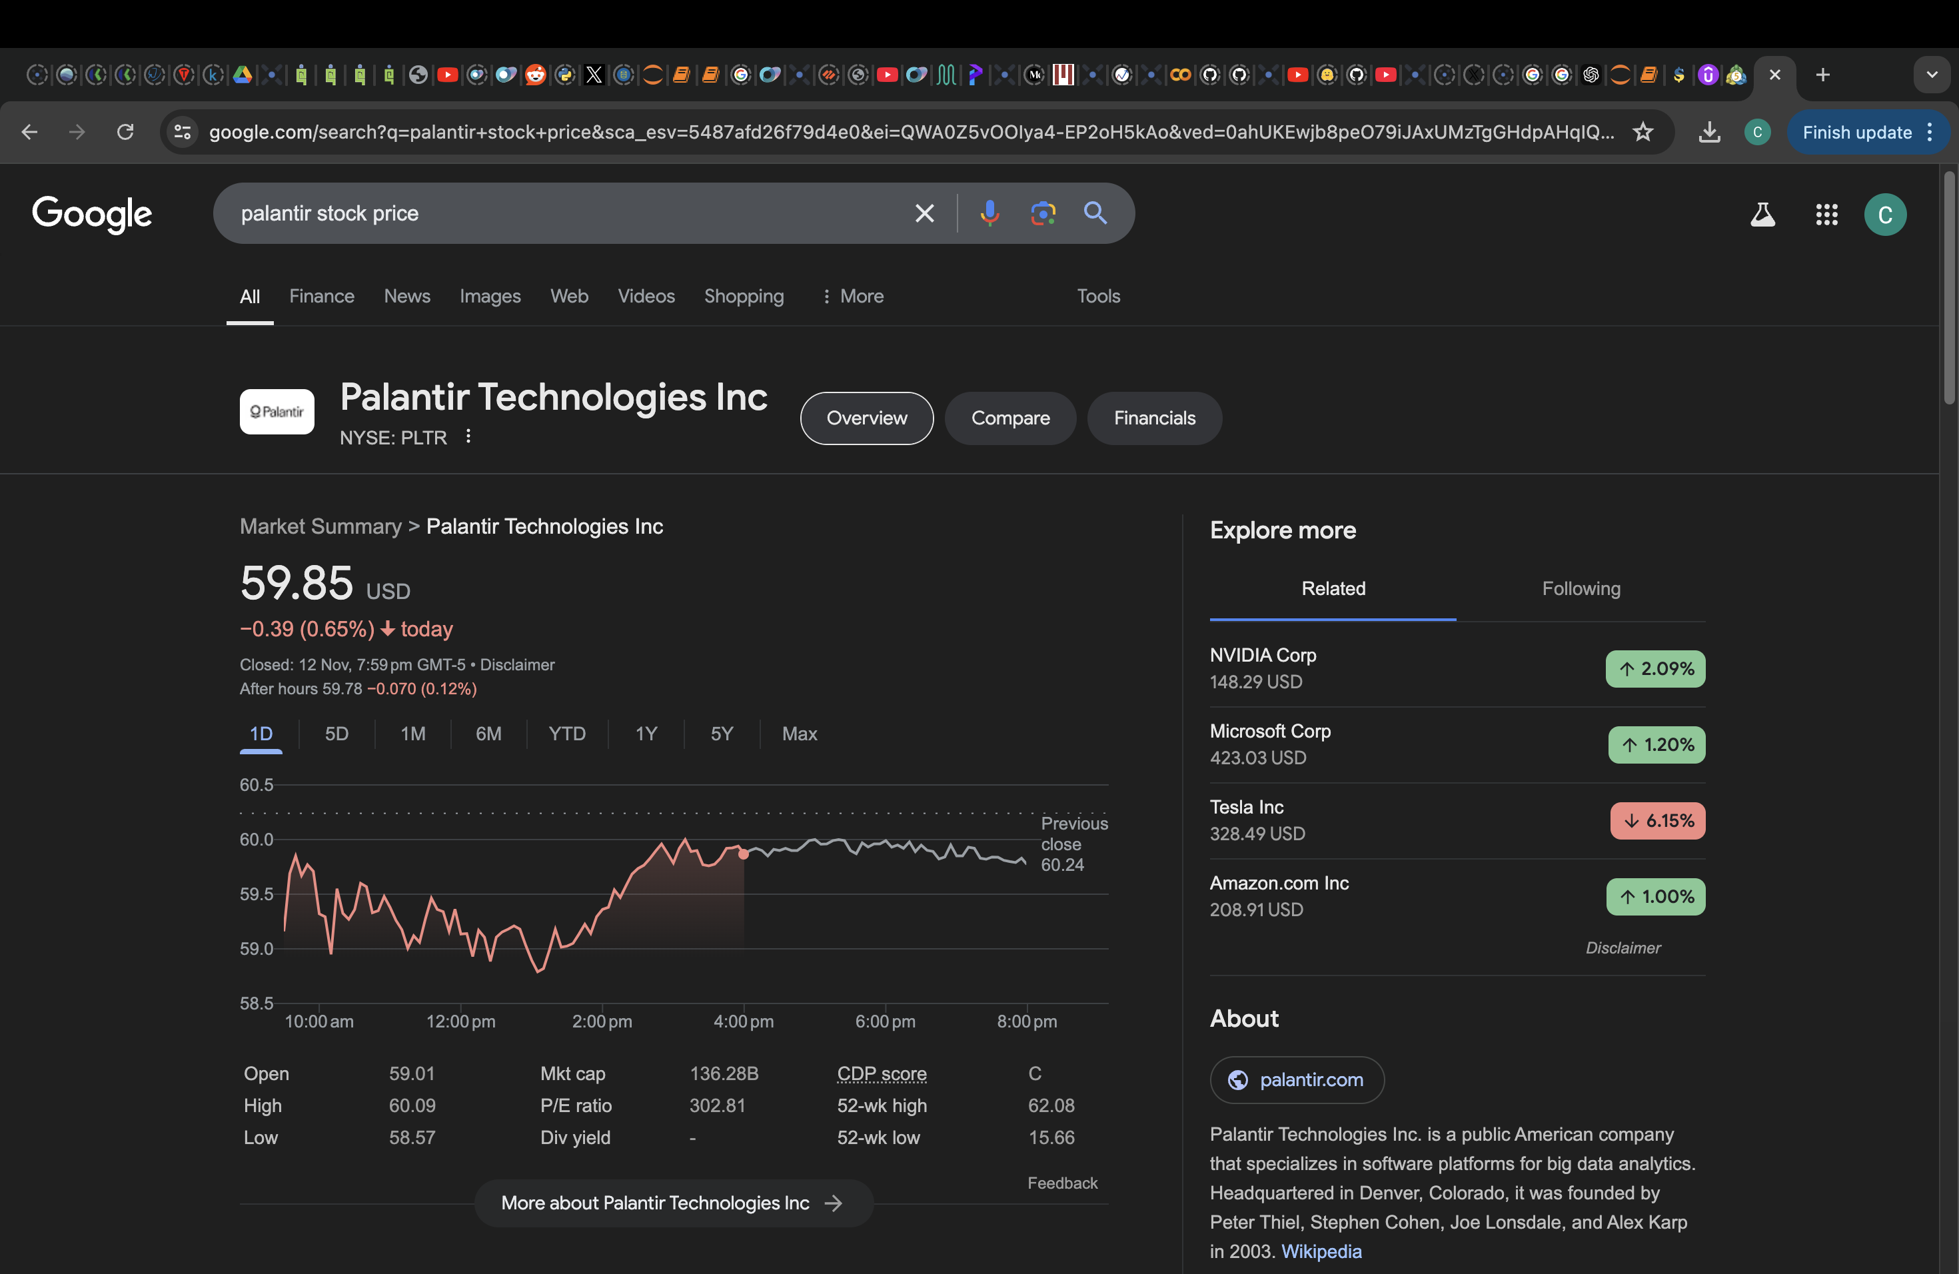

Actual Stock Price – Screenshot from Google

**4.3 Summary of Result Finding**

The multi-plot chart below (Figure 4.3.1) provides a comprehensive view of the model’s performance across different data segments. In the training plot, we observe that the model closely aligns with actual prices, suggesting strong learning from historical data. However, some overfitting may be present, as indicated by its high sensitivity to short-term fluctuations. The validation plot demonstrates the model's ability to generalize, capturing overall price trends though with some deviation, as shown by a higher Mean Absolute Error (MAE) compared to the training set. Finally, the 30-day future prediction plot suggests a positive forecast for Palantir’s stock price, although caution is advised given that predictive accuracy typically diminishes with time. This forecast serves as a potential indicator but may benefit from additional market variables for enhanced reliability.

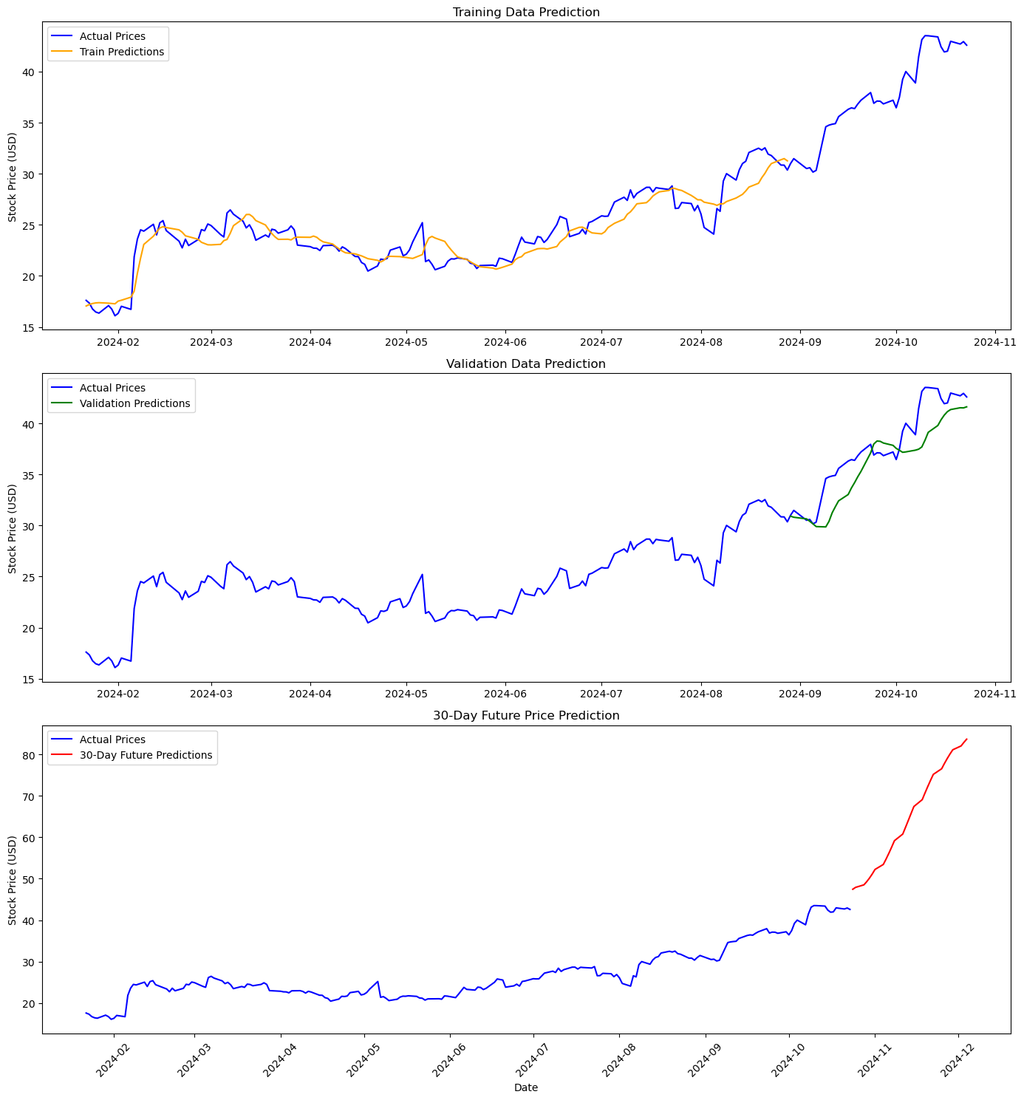

Figure 4.3.1

Figure 4.3.1

**4.4 Correlation with Sentiment**

The scatter plot below (Figure 4.4.1) illustrates the correlation between sentiment scores (from VADER analysis on Reddit posts) and Palantir’s stock closing price. The correlation coefficient for this data is approximately **0.42**, indicating a moderate positive correlation. This suggests that as sentiment scores increase (i.e., posts are more positive), there is a tendency for the stock price to also increase.

Key observations:

* **Positive Sentiment Influence**: Points in the higher sentiment score range (0.5 to 1.0) appear to be associated with higher stock prices, supporting the idea that positive market sentiment might influence price growth.
* **Neutral Sentiment Cluster**: There is a noticeable concentration of points around a sentiment score of 0, which aligns with neutral sentiment posts. The stock price varies widely within this neutral sentiment range, indicating other factors also influence price beyond sentiment alone.
* **Variability**: Despite the moderate positive correlation, there is substantial scatter, suggesting that while sentiment plays a role, it is not the sole determinant of stock price movement.

Correlation between sentiment score and stock price: 0.4219859268906889

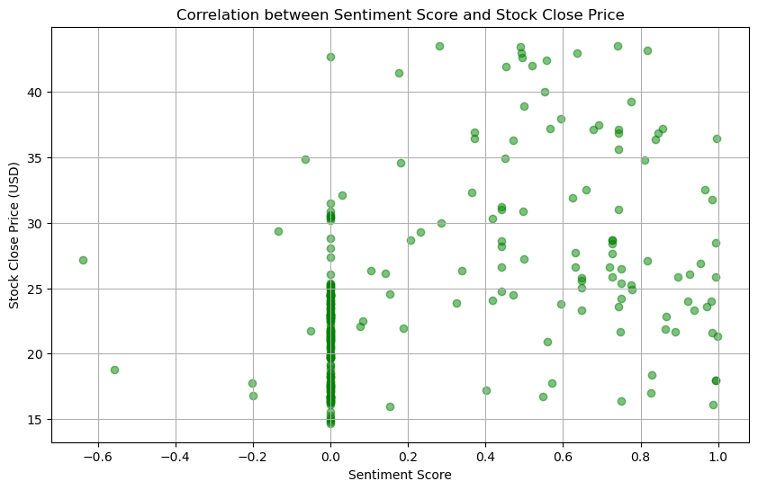

Figure 4.4.1

**Effectiveness of Integrating Sentiment Data**: Sentiment analysis data was integrated to add an additional layer of information reflecting investor sentiment. Days with higher positive sentiment scores were observed to generally coincide with upward stock movements, suggesting that sentiment data captures the mood of retail investors, which can have an impact on Palantir’s stock price.

However, the model’s ability to fully leverage this sentiment information remains limited, as sentiment data alone may not entirely predict price changes, particularly during volatile periods. Further analysis could explore whether sentiment weights could be adjusted dynamically or if additional sources of sentiment data (e.g., Twitter or financial news) could improve the model's predictive capability.

Overall, incorporating Reddit sentiment data provided some benefits in capturing retail investor sentiment, yet further improvements could be achieved by expanding the sentiment dataset or exploring more advanced approaches to sentiment integration.

**5. Conclusions and Future Work**

This section provides a summary of the findings from the project, discusses the challenges encountered, and explores potential future directions for improving the model, including scalability considerations and possible enhancements to data sources and modeling approaches.

**5.1 Summary of Findings**

The primary goal of this project was to develop a predictive model for Palantir's stock price by combining historical stock data with sentiment data from Reddit. Using an LSTM (Long Short-Term Memory) neural network, the model demonstrated the ability to capture general price trends and make short-term forecasts. The integration of sentiment data added contextual information from retail investor discussions, particularly those in the r/stocks subreddit, which allowed the model to reflect broader investor sentiment.

The findings suggest that sentiment data from Reddit has a modest impact on stock price prediction, particularly for a company like Palantir that attracts significant retail investor interest. Days with higher sentiment scores often corresponded to upward price movements, indicating a potential correlation between sentiment and price trends. However, the model's accuracy was somewhat limited by the availability and scale of the sentiment data, as well as by challenges in adapting to market volatility. Overall, the LSTM model captured general trends but showed limitations in predicting abrupt price fluctuations, which could be improved by more advanced techniques and larger datasets.

**5.2 Challenges Faced**

Several challenges were encountered during the project, which affected the model’s accuracy and generalizability:

1. **API Rate Limits**: The Reddit API, when accessed for free, has limitations on the number of requests and the volume of data that can be retrieved within a specific time frame. This limitation constrained the amount of sentiment data available, as only a limited number of posts could be pulled each day. Additionally, sentiment data was limited to the r/stocks subreddit, which may not fully represent broader sentiment.
2. **Data Sparsity**: On some dates, especially those with lower retail interest or reduced online activity, few or no Reddit posts mentioned Palantir. This introduced sparsity in the sentiment data, as days with no posts were assigned a default sentiment score of zero. This lack of data continuity affected the model’s ability to learn consistent sentiment patterns over time.
3. **Model Accuracy Constraints**: While the LSTM model successfully captured general price trends, it struggled to predict price changes during periods of high volatility. The mean absolute error (MAE) for the test set was higher than for the training set, suggesting that the model may be slightly overfitting to the training data or lacking robustness to predict unseen data effectively.

**5.3 Scalability and Future Improvements**

To improve model performance and scalability, several enhancements could be considered. These include the use of big data technologies, GPU acceleration, and the integration of additional data sources.

1. **Use of Big Data Technologies**: With access to larger datasets, this project could be scaled using big data frameworks like Apache Spark or Hadoop, which would allow for distributed data processing. By leveraging big data technologies, the approach could incorporate a much larger volume of sentiment data from multiple social media platforms, as well as historical data from additional companies. This would enhance the model's ability to generalize by providing richer data for training. Furthermore, distributed processing could facilitate parallelized sentiment analysis, increasing efficiency when dealing with large datasets.
2. **Utilizing GPUs**: The use of GPU acceleration could significantly improve the training speed for larger models or datasets. LSTM models are computationally intensive, and training on large time-series data can be time-consuming. By utilizing GPUs or even TPUs, training times could be reduced, allowing for faster experimentation and tuning of model parameters. This would also enable more complex models with additional layers or units, which might improve accuracy in capturing intricate patterns in the data.

**5.4 Future Directions**

Several future directions could be pursued to enhance the predictive accuracy and robustness of the model:

1. **Incorporating More Data**: To improve the quality and representativeness of sentiment data, additional data sources could be incorporated, such as financial news headlines, other social media platforms (e.g., Twitter), or investor forums. These sources would provide a more comprehensive view of sentiment and help capture broader market perspectives beyond Reddit alone. Additionally, historical stock data from multiple companies could be incorporated to allow the model to learn general market patterns, which might improve predictions.
2. **Algorithm Improvements**: Beyond LSTM, more advanced models could be explored to handle complex market dynamics. Some potential approaches include:

* **Transformers**: Transformer-based architectures have shown promising results in time-series forecasting and NLP tasks, as they can capture long-term dependencies more effectively than LSTMs. Applying a transformer model might enhance the ability to predict complex stock price patterns, especially in volatile markets.
* **Hybrid Models**: Combining LSTM with other types of models, such as convolutional neural networks (CNNs) or attention mechanisms, could help capture both local and global patterns in the data, leading to more robust predictions.
* **Ensemble Methods**: Ensemble techniques that combine multiple models, such as LSTM with random forests or gradient boosting models, could be considered to improve accuracy by leveraging the strengths of different algorithms.

In summary, this project demonstrated the potential of combining stock price data with sentiment analysis from Reddit to predict stock prices for Palantir. While the model achieved reasonable accuracy in capturing price trends, future improvements in data collection, model complexity, and computational power could further enhance predictive performance. Expanding the model to include additional data sources and more advanced algorithms holds promise for creating a robust, scalable stock price prediction framework that better adapts to dynamic market conditions.